

08

**Fall**

Unicorn Media Inc.

SNS Content Ingest

Technical Setup Guide

VERSION: 1.0

Last Revision Date: 08/20/2011

©2013

**SNS Content Ingest API**

SNS Content Ingest is the service that allows for the automated ingest of assets and metadata from an Amazon SNS Topic into the Unicorn Media platform. The SNS Ingest API waits for SNS Messages from all topics that it is subscribed to. Content is passed to the API by posting a Notification message to a topic that SNS Ingest API is subscribed to.

**Process**

For the Unicorn Media SNS Ingest API to receive messages published to your topic, you should first send a Create Subscription Message to the API's receiving endpoint from the AWS Management Console. The API’s HTTP receiving endpoint is the following:

US Hostname: <http://snsingest.unicornmedia.com/api/sns>

EU Hostname: <http://snsingest-eu.unicornmedia.com/api/sns>

The SNS Ingest API will automatically accept the subscription confirmation, and it is now ready to ingest content sent via a Notification SNS message.

The SNS Ingest API is capable of ingesting content via HTTP links and Amazon S3 Buckets. To allow the Ingest API permission to receive messages from your Amazon S3 bucket(s), you will need the Unicorn Media IAM ARN.  "arn:aws:iam::453163911362:root" This permission policy is configured within your AWS account under Permissions for the S3 Bucket. Note that if your S3 content is set to be publically available, configuring this permission policy is not necessary.

If you are not using Amazon S3 Buckets to send your content, the following section can be ignored.

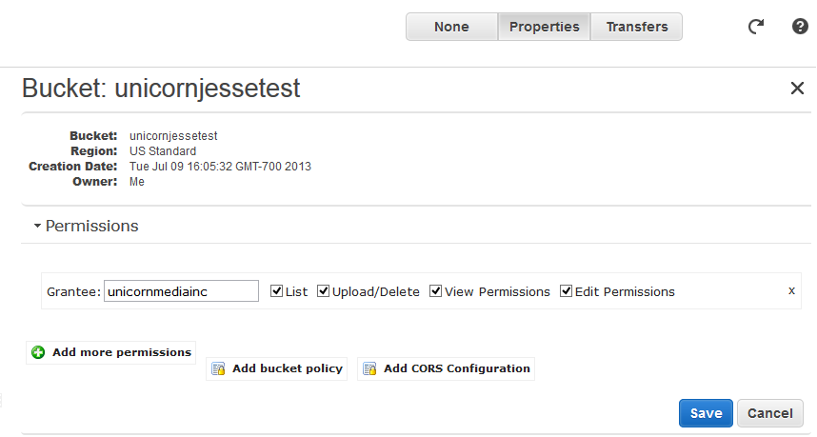

Example Message to Allow Permissions to an S3 Bucket

{

"Version": "2008-10-17",

"Id": "Policy1373997962433",

"Statement": [

{

"Sid": "Stmt1373997941057",

"Effect": "Allow",

"Principal": {

"AWS": "arn:aws:iam::453163911362:root"

},

"Action": "s3:*",

"Resource": "arn:aws:s3:::UnicornTest/*"

}

]

}

Where the highlighted portion will be the Amazon ARN of the S3 Bucket being used to pass content via S3 URLs.

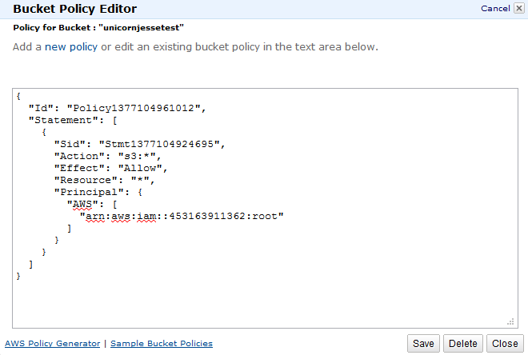

**Publishing Content to the SNS Ingest API**

Once a topic is established and the Unicorn Media AWS has been subscribed to it, any Notification message published to the topic will be ingested to the Unicorn Media system for transcoding and processing. Messages may be manually published through the AWS Management Console, or by using the Amazon Web Services SDK. The content and its metadata should be published to your topic via a JSON string following the format below. The SNS Ingest API will then pick it up and processing of the content will begin.

See this example of a JSON String that would be used in an SNS notification message to send content to the API for processing:

<http://demo.umedia.com/Amazon/snstranscoderequest.html>

A table describing all keys used in the request is contained at the bottom of that page.

**Item Notifications via SNS Messages**

Unicorn Media can also pass SNS notifications back to your topic, informing you of published items or any errors that may have occurred. These notifications can be for profile complete notification or error notification. The SNS Topic for either notification must be a topic that the Unicorn AWS account has permission to publish to. To enable the SNS Ingest API to publish notifications to your topic(s), you will first need to grant permission to the Unicorn Media IAM ARN.  "arn:aws:iam::453163911362:root" This is done within the AWS Management Console

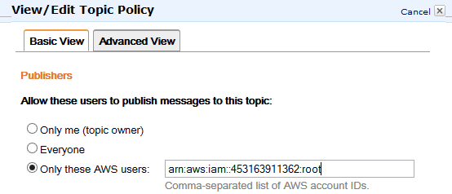

If you would like Item Complete Notifications and Error Notifications sent to different SNS Topics, each topic will need to be set up accordingly, and the correct permissions set.

If you would like to receive Unicorn Once URLs in the item notifications, an application GUID must be set up for use, which is saved within your domain configuration. Unicorn Media Client Services team will be happy to set up this configuration for you.

Example of an SNS Item Notification (with Once URL)

{

  "___version" : "1.0",

  "jobId" : "<GUID>",

  "onceUrl" : " http://onceapi0.phx1.qa0.unicornapp.com/now/od/auto/88f98026-95a7-4fe9-992a-94b6a1580483/819add68-2b34-442e-86a5-82204835b4ec/48ddf3dd-3849-4b50-8086-b9391afb6e90/content.once”,

  "passThruMetadata" : "<JSON string sent in with ingest>",

  "status": "Completed"

}

Example of an SNS Error Notification

{

  "___version" : "1.0",

  "errorCode" : "500",

  "errorMessage" : "There was an error in the Unicorn Media System",

  "jobId" : "<GUID>",

  "passThruMetadata" : "clob",

  "status" : "Error"

}

**SUPPORT & CONTACT INFORMATION**

New Release delivery method/policy:

* Customers are notified via email regarding platform and feature releases
* Unicorn Media Client Services manages all major platform changes that would affect a customer’s workflow via personalized communication, planning and 24/7/365 Support

￼

**Online**

Home Page: [www.unicornmedia.com](http://www.unicornmedia.com)

Contact Page: <http://unicornmedia.com/contact>

Client Services E-mail: [support@unicornmedia.com](mailto:support@unicornmedia.com)

**Phone**

Toll Free: **877-8-UNICORN (877-886-4267)**

Client Support Arizona Local: **480-214-4879**

Corporate Arizona Local: **480-214-6464**

**Hours of Operation**

Client Support Services:

Standard: **Monday – Friday, 6:00 AM – 6:00 PM**

On-Call Support: **24 x 7 x 365**

Corporate: **Monday – Friday, 8:00 AM – 5:00 PM**

￼￼￼**Client Services Prerequisites**

***New Issue:***

Your support representative will ask for certain information when you call. Please have the following information available prior to contacting Client Services:

* Service name and version: Click Help > About to obtain version
* Internet Browser Name and Version (e.g. MS Internet Explorer 8)
* Screen shot or complete transcript of error received if applicable
* Description of problem
* Summation of steps that produced the problem/error
* E-mail a ZIP file containing any relevant screen shots, error messages or files to the support email above

***Existing Issue:***

Please have your Support Ticket number ready when you call as well as all new screenshots and steps necessary to determine the issue.